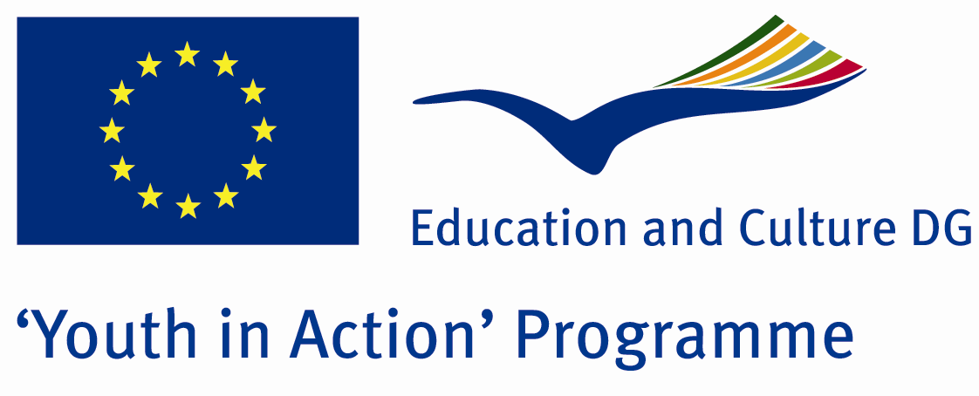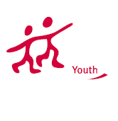

Action 1.1
Project Summary; As the youth interested in local politic issues to introduce our city and country’s political system, we want to share with you the hospitability of the citizens and natural beauties in Anatolian side of our country. By means of our project we aim more people can deal with politics and democratic life conditions so that they can have ideas about the political system in our city and around the country.

Project Title; Suggest Your Ideas to Anatolian Politicians
Date and Venue ; 16-23 2013 February Turkey
Place: Ordu.

Target Group ; Municipalities, City Councils and Non-Governmental organizations,
youth groups,culture and art groups,e.t.c

Participants ; 5 people from each country (over 18 -25 ). Totally 7 countries.

Conditions ; Accommodation, board and programme costs will be financed through European Commission Youth in Action Programme . Travel costs will be reimbursed in 70% (APEX Tarrifs). Organizations from all 27 EU member countries plus Liechtenstein , Norway and Iceland are eligible to take part.

Working language: English

Organisator group:Group Young Anatolian Politicians

How to apply: If you are interested, please send your Part III forms to
by e-mail please (in word file). Scan Part3 format is enough for application.(Fulfilled Part III which you can find in the attachment, of course signed and stamped) ..

Contact e-mail: youngpoliticians24@gmail.com
Group e-mail: groupsymrnes@gmail.com

Deadline to apply:20.09.2012

